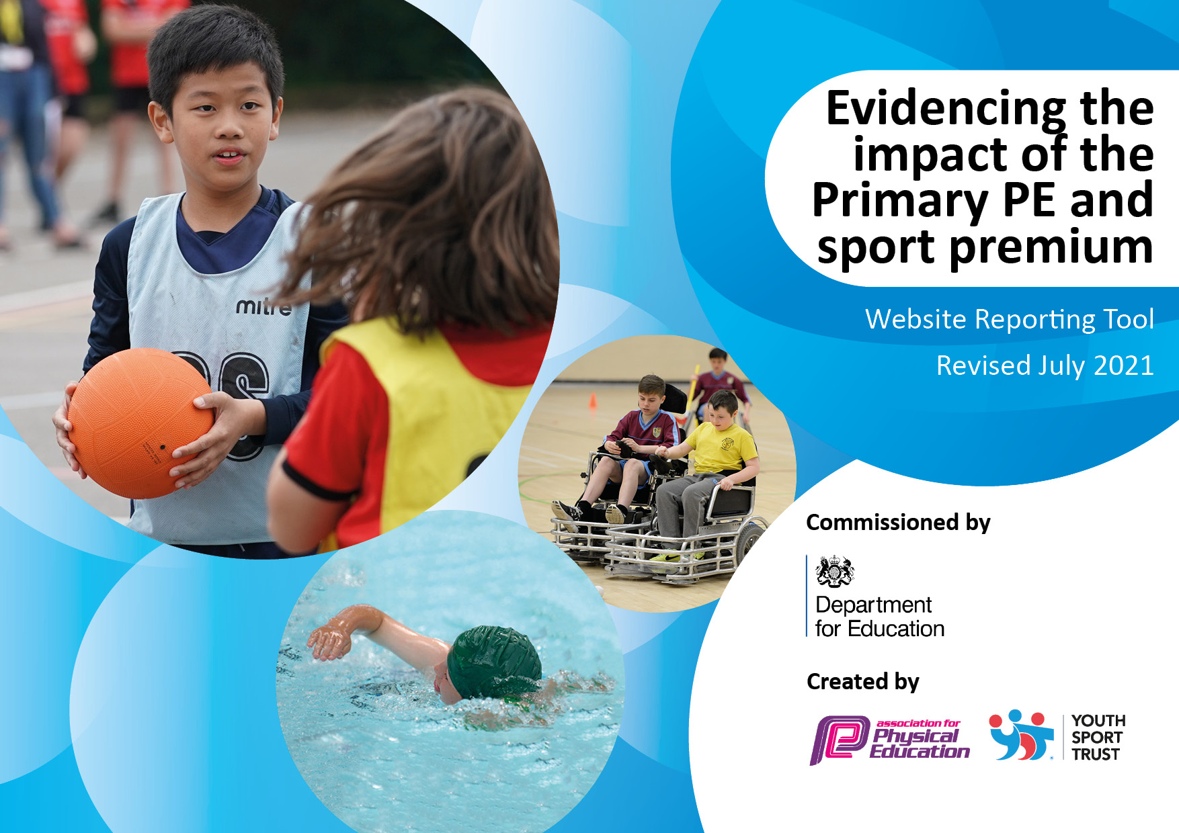
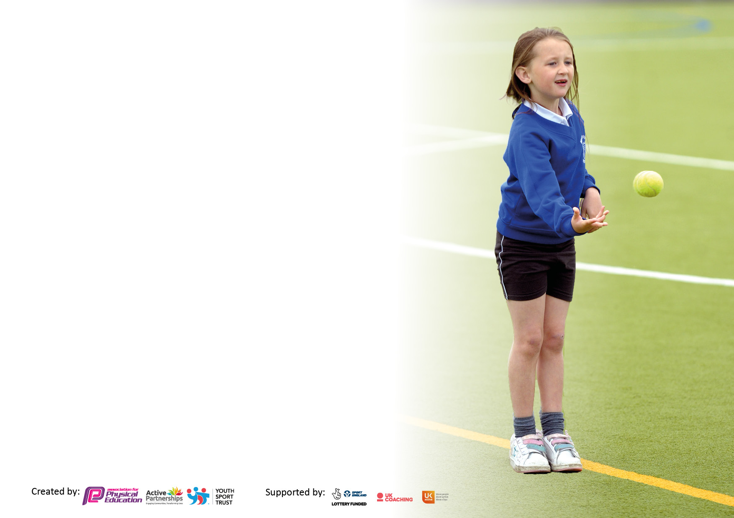

It is important that your grant is used effectively and based on school need. The Education Inspection Framework makes clear there will be a focus on ‘whether leaders and those responsible for governors all understand their respective roles and perform these in a way that enhances the effectiveness of the school’.

Under the Quality of Education Ofsted inspectors consider:
Intent - Curriculum design, coverage and appropriateness
Implementation - Curriculum delivery, Teaching (pedagogy) and Assessment
Impact - Attainment and progress

To assist schools with common transferable language this template has been developed to utilise the same three headings which should make your plans easily transferable between working documents.

Schools must use the funding to make additional and sustainable improvements to the quality of Physical Education, School Sport and Physical Activity (PESSPA) they offer. This means that you should use the Primary PE and sport premium to:

- Develop or add to the PESSPA activities that your school already offer
- Build capacity and capability within the school to ensure that improvements made now will benefit pupils joining the school in future years
- The Primary PE and sport premium should not be used to fund capital spend projects; the school’s budget should fund these.

Pleasevisitgov.ukfortherevisedDfEguidanceincludingthe5keyindicatorsacrosswhichschoolsshoulddemonstrate animprovement.Thisdocumentwillhelpyoutoreviewyourprovisionandtoreportyourspend.DfEencouragesschools to use this template as an effective way of meeting the reporting requirements of the Primary PE and sport premium.

We recommend you start by reflecting on the impact of current provision and reviewing the previous spend.

Schools are required to publish details of how they spend this funding, including any under-spend from 2019/2020, as well as on the impact it has on pupils’ PE and sport participation and attainment. All funding must be spent by 31st July 2022.

We recommend regularly updating the table and publishing it on your website throughout the year. This evidences your ongoing self-evaluation of how you are using the funding to secure maximum, sustainable impact. Final copy must be posted on your website by the end of the academic year and no later than the 31st July 2021. To see an example of how to complete the table please click HERE.
Created by: Supported by:

Details with regard to funding
Please complete the table below.

Total amount carried over from 2019/20 | £1796 | £
Total amount allocated for 2020/21 | £17100 | £
How much (if any) do you intend to carry over from this total fund into 2021/22? | £0 | £
Total amount allocated for 2021/22 | £17090 | £
Total amount of funding for 2021/22. To be spent and reported on by 31st July 2022. | £3000 | £
Swimming Data
Please report on your Swimming Data below.

Meeting national curriculum requirements for swimming and water safety.

N.B. Complete this section to your best ability. For example you might have practised safe self-rescue techniques on dry land which you can then transfer to the pool when school swimming restarts.
Due to exceptional circumstances priority should be given to ensuring that pupils can perform safe self-rescue even if they do not fully meet the first two requirements of the NC programme of study
What percentage of your current Year 6 cohort swim competently, confidently and proficiently over a distance of at least 25 metres?  N.B. Even though your pupils may swim in another year please report on their attainment on leaving primary school at the end of the summer term 2020.  Please see note above | 94.44%
What percentage of your current Year 6 cohort use a range of strokes effectively [for example, front crawl, backstroke and breaststroke]?  Please see note above | 83.333%
What percentage of your current Year 6 cohort perform safe self-rescue in different water-based situations? | 27.78%
Schools can choose to use the Primary PE and sport premium to provide additional provision for swimming but this must be for activity over and above the national curriculum requirements. Have you used it in this way? | No

Action Plan and Budget Tracking
Capture your intended annual spend against the 5 key indicators. Clarify the success criteria and evidence of impact that you intend to measure to evaluate for pupils today and for the future.

Academic Year: 2020/21 | Total fund allocated: £20,090 | Date Updated:
Key indicator 1: The engagement of all pupils in regular physical activity – Chief Medical Officers guidelines recommend that primary school pupils undertake at least 30 minutes of physical activity a day in school |  |  |  | Percentage of total allocation:
 |  |  |  | 35%
Intent | Implementation |  | Impact
Your school focus should be clear what you want the pupils to know and be able to do and about  what they need to learn and to  consolidate through practice: | Make sure your actions to achieve are linked to your intentions: | Funding allocated: | Evidence of impact: what do pupils now know and what can they now do? What has changed? | Sustainability and suggested next steps:
To achieve a higher percentage of children accessing the school competitions both virtually and physically for organised active games and sports than last year which reached 26% for whole school participation during playtimes and dinner time.  Prioritise EYFS to build confident physical foundations that will stay with them throughout their school career. | HT-TA to be paid extra time after school to plan some intra comps for teachers and TA’s to run at various points throughout the year making sure the activities appeal to a wide range of children. Coach to be brought in for afternoon skills support and afterschool clubs.  To maintain the new EYFS bikes so that the children gain confidence daily on bikes and scooters developing gross motor skills, confidence and spatial awareness. | £6000 wage implication for Helen and Ben for year PE lessons taught and intra comps.  £1100 | Taken part in more competitions and each year groups have had an opportunity to be part of a competitive sporting events. Had a KS1 and KS2 sports day involving all children taking part in different competitive and team events. Playtimes have been more structures and more opportunity for equipment to be used has impacted the children’s skill level which shows within their PE lessons.  Coach to free PLT time for upskilling staff in support in afternoon PE sessions. As well as Provided afterschool clubs linked to upcoming competitions.  The EYFS staff are confident that the additional bikes are still helping and will continue to for new reception children by improving the physical development aspect of the EYFS curriculum. | Discuss with SLT about playtime structure next year and keep the offer of simple play equipment on the yard.  Keep this target and improve upon next year. B.S behaviour/sport TA football competitions and friendlies.  Keep this target for upkeep of afterschool clubs to support skill building of sports and competition skills. To continue to support staff with upskilling in all area of PE development.  Keep them maintained for upkeep to be serviced once a year and plan time for more focused bike time.
Key indicator 2: The profile of PESSPA being raised across the school as a tool for whole school improvement |  |  |  | Percentage of total allocation:
 |  |  |  | 0%
Intent | Implementation |  | Impact
Your school focus should be clear what you want the pupils to know and be able to do and about  what they need to learn and to  consolidate through practice: | Make sure your actions to achieve are linked to your intentions: | Funding allocated: | Evidence of impact: what do pupils now know and what can they now do? What has changed? | Sustainability and suggested next steps:
To use both curriculum PE and all school sports as an opportunity to teach character and values impacting behaviour and adding to the whole school ethos.  To achieve high quality PE lessons and a curriculum timetable that meets the sports teachers time requirements. | Teachers assess these PE values (spirit, commitment, discipline and fair play) alongside our school values as part of the PE curriculum, share the PE and school value with parents’ vis class dojo.  PE co-ordinator to teach Class 2, highly qualified TAs to teach in Class 3 and 4 PE lessons to ensure high quality PE lessons, using core tasks to assess and progress children’s learning.  Meeting with school sports co-ordinator to upskill staff on areas for development/practical.  Curriculum timetable to be looked at in order to increase PE time in KS2, Swimming 4/5 when return – extra swim for year 6. | Free  Included in wage payment. | PE and School values are used weekly within lessons and rewards are given and shared on class dojo.  Assessment in this area has improved, PE was able to take part in a book scrutiny. It is clear where the children’s attainment levels are and where the need to progress too.  PE co-ordinator is observing feedback on surveys, conversations and questionnaires to support staff in areas of development.  This has only impacted year 3 and 4 which has given them more PE time. | To show praising children with show HT/AB and the sports ambassadors to oversee the sports board to include the results of the intra, personal best and inter competitions. Display and give sports star relating to school values and school games values during weekly assembles.  To keep this the same as much as possible, any outside agencies to be used as extracurricular rather than interrupting curriculum PE.  Year 4 and 5, 6 are still in need of more PE time to be available to them. Time table to have each year in KS2 with PE time slot.

Key indicator 3: Increased confidence, knowledge and skills of all staff in teaching PE and sport |  |  |  | Percentage of total allocation:
 |  |  |  | 25%
Intent | Implementation |  | Impact
Your school focus should be clear | Make sure your actions to | Funding | Evidence of impact: what do | Sustainability and suggested
what you want the pupils to know | achieve are linked to your | allocated: | pupils now know and what | next steps:
and be able to do and about | intentions: |  | can they now do? What has
what they need to learn and to |  |  | changed?:
consolidate through practice:
To embed the new progressive curriculum that teaching staff feel confident to deliver. Refresh PE skills/knowledge of teachers for good practise. | Accordance to facilitate and help with high quality dance and gymnastic teaching in school.  PLT meeting for AB  Coach to support in afternoon PE lesson. To help upskill teacher and develop techniques and strategies to help support during PE lesson with behaviour management/ warm up and cool down activities/ teaching sport skills. | £5016 after school coach | This resources is used daily to monitor all aspects of PE, previous PE lead is confident to support and train new PE Lead to deliver and other uses are using it effectively to help support teaching. The use of it for assessment purposes still need some CPD. | Staffing changes next year will require more CPD to be done on the APP. In order for it to be used consistently throughout school. SSP deliver PE app training.  Evaluating the usage of this resource throughout the year will be a priority and support the delivering of gymnastics and dance more confidently.
Key indicator 4: Broader experience of a range of sports and activities offered to all pupils |  |  |  | Percentage of total allocation:
 |  |  |  | 20%
Intent | Implementation |  | Impact
Your school focus should be clear | Make sure your actions to | Funding | Evidence of impact: what do | Sustainability and suggested
what you want the pupils to know | achieve are linked to your | allocated: | pupils now know and what | next steps:
and be able to do and about | intentions: |  | can they now do? What has
what they need to learn and to |  |  | changed?:
consolidate through practice:
Enrich the curriculum with a wider choice of sports that are not generally offered at school. | To use the Primary dance uk resource to enrich PE, school sports competitions.  Children to be involved in an outdoor education day at an outdoor adventure and to be offer during the day alterative so that children can experience other activates for year 5/6 including outdoor adventure trip.  As local restrictions and school risk assessments are in place regarding sports coaches and afterschool clubs’ alternatives during school time in addition to their PE lessons. | £1000  £3000  Hothersall lodge, staff expenditure and coach | Providing children with enrichment and experiences that could contribute to future physical hobbies.  To offer the OOA experience after SATs was a great idea for the children. It got them out into fresh air and building skills like team work, communication and to help children’s mental health enjoying outdoors. | Extra-curricular sports will be a priority next year, BSSP have already released their offer so we are now able to utilise this effectively.

Key indicator 5: Increased participation in competitive sport |  |  |  | Percentage of total allocation:
 |  |  |  | 20%
Intent | Implementation |  | Impact
Your school focus should be clear | Make sure your actions to | Funding | Evidence of impact: what do | Sustainability and suggested
what you want the pupils to know | achieve are linked to your | allocated: | pupils now know and what | next steps:
and be able to do and about | intentions: |  | can they now do? What has
what they need to learn and to |  |  | changed?:
consolidate through practice:
Continue to provide a wide range of competitive opportunities for our children at a range of levels. Embed intra school competitions within the school week including in the curriculum and at break times.  Buy into local SSP to ensure continuity and growth of local infrastructure. Universal offer for pupils and coordinated support packages. Established links with other local providers. | To join as many competitions as possible utilising the Burnley school partnership. | £5550 | We were able to access KS1 and 2 athletics which 8 children from each KS took part in.  6 children took part in a virtual gymnastic competition.  16 year 5/6 and 16 year 3/4 children took part in cross county.  11 year 6 took part in football competition.  12 year 3/4 girls too part in football skills event and games.  Whole school took part in KS1 and KS2 sports day. | To take part in more competitions each half term and to increase the number of KS1 sport events.

Signed off by
Head Teacher: | Amourelle Leyland
Date: | 31.07.22
Subject Leader: | Alex Bradley
Date: | 31.07.22
Governor: | David Edmondson
Date: | 31.07.22

