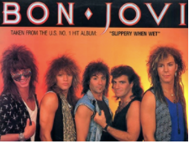

Key Questions –

* How has music changed over time?
* Can you move in time to the music?
* Do you like this song? Why?
* How does the music make you feel?
* What instruments can you hear in the music?
* Can you identify the artist?
* Can you invent rhythmic and melodic patterns?

Key skills –

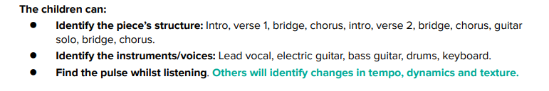

* Write their own version of the song adapting lyrics
* Singing together in a round, as a solo or a duet

What I will be taught –

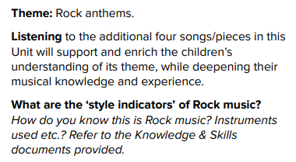

What I should already know –

* How to find the pulse of a song and move to it
* Simple chords on instruments
* Listening to different songs and giving opinions on them
* Simple improvisation with instruments
* Singing in groups
* Different genres of music and how they sound

Key vocabulary –

