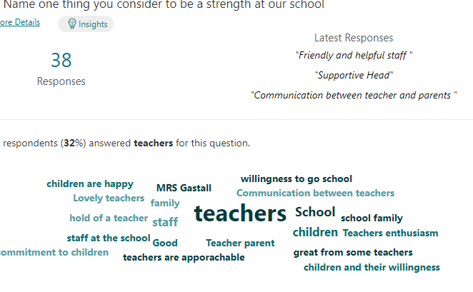

**32% of respondents think that our teachers are a strength of our school. Here are some of the lovely things they said about us!**