 |  | Strongly agree | Agree | Disagree | Not applicable
1 | My child feels happy at this school. | 69% | 31% | 0 | 0
2 | My child feels safe at this school. | 73% | 27% | 0 | 0
3 | The school makes sure it’s pupils are well behaved. | 49% | 47% | 4% | 0
4 | My child has been bullied at this school and the school has dealt with it quickly and effectively | 9% | 8% | 4% | 64%
5 | The school makes me aware of what my child will learn throughout the year | 42% | 49% | 9% | 0
6 | When I have raised concerns within the school, they have been dealt with properly | 51% | 44% | 2% | 0
7 | My child has special needs and the school has given them the support they need | 13% | 4% | 7% | 76%
8 | The school has high expectations for my child | 44% | 51% | 4% | 0
9 | My child does well at this school | 47% | 47% | 7% | 0
10 | The school lets me know how my child is doing | 47% | 47% | 7% | 0
11 | There is a good range of subjects available to my child at this school | 57% | 41% | 2% | 0
12 | My child can take part in clubs and activities at this school | 29% | 44% | 27% | 0
13 | The school supports my child's wider, personal development | 36% | 49% | 16% | 0
14 | I would recommend this school to another parent | 53% | 44% | 2% | 0
The main concern felt from parents was that more clubs were needed. Since this survey, we have run more clubs including times tables clubs, football club, booster clubs, multi-sports, athletics and cross country. We are looking to increase this further in the next academic year.

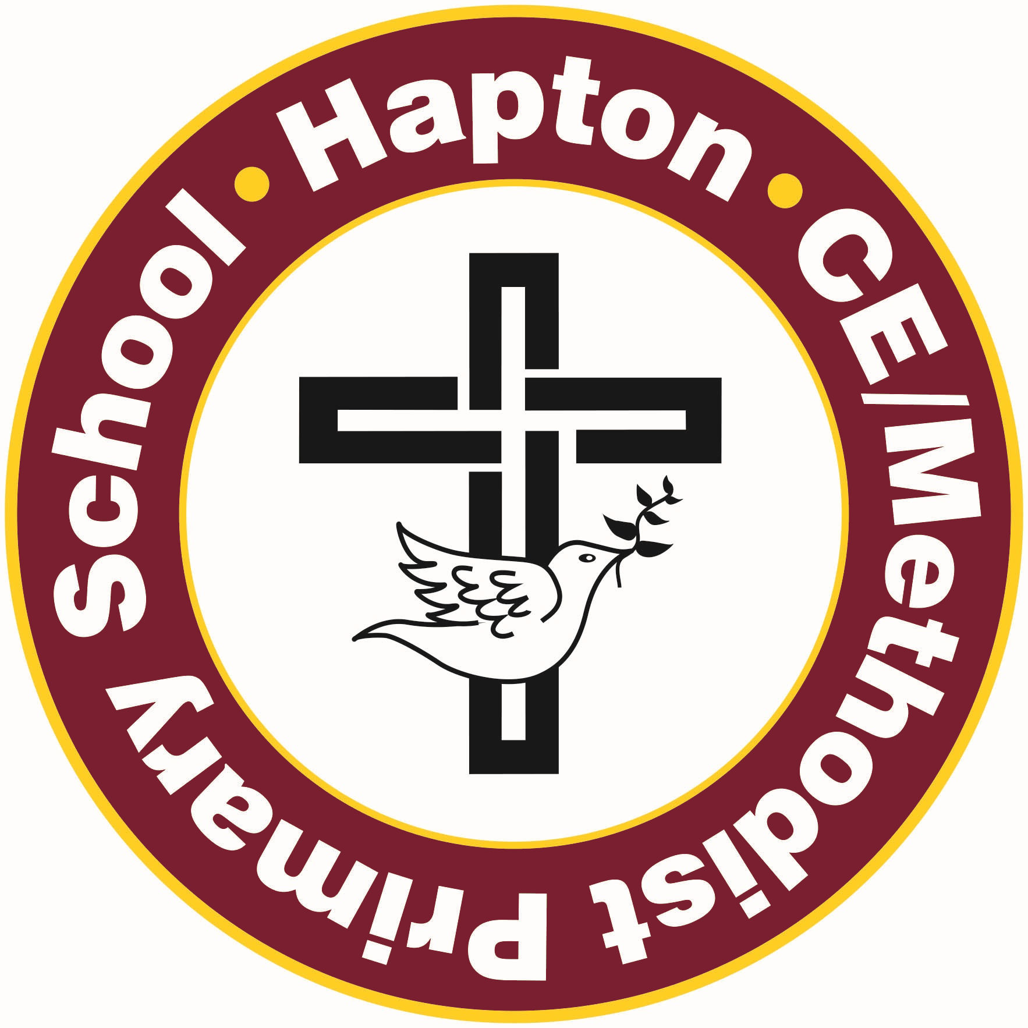
Hapton C of E/Methodist Primary School Parental Questionnaire Spring 2022
45 responses were submitted

