

Key Questions –

* Can you find the pulse of the music?
* Can you move in time to the music?
* Do you like this song? Why?
* Which notes have you used?
* Can you improvise?
* How does the music make you feel?

Key skills –

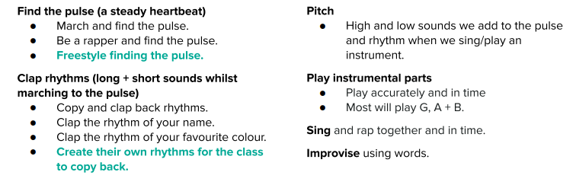

What I will be taught –

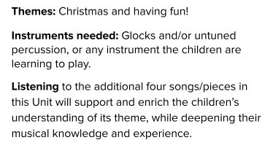

What I should already know –

* How to find the pulse of a song and move to it (basic)
* Simple chords on instruments
* Listening to different songs and giving basic opinions on them

Key vocabulary –

