Early Years Areas of Learning and Development - RE
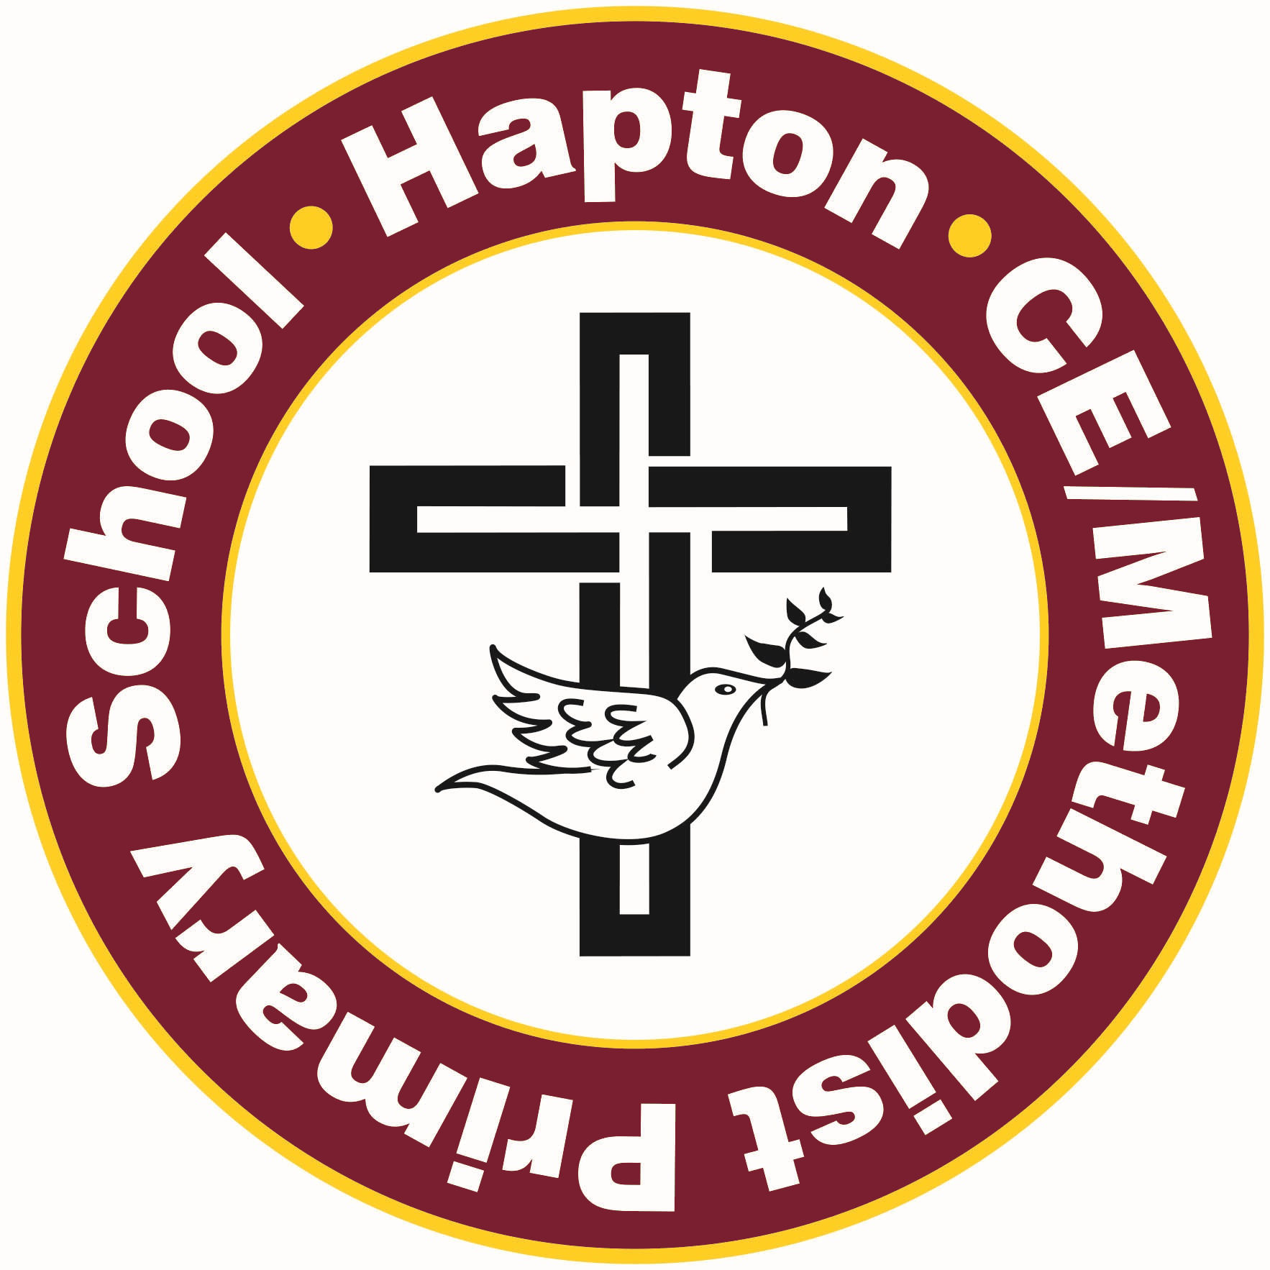

The areas of learning and development covered by the EYFS Units in the syllabus we use (Questful RE) are
- communication and language
- personal, social and emotional development
- literacy
- understanding the world
- expressive arts and design

Early Learning Goals
The content of the EYFS units in this syllabus contribute to the attainment of the following early learning goals

Communication and Language
ELG: Listening, Attention and Understanding
Children at the expected level of development will
- listen attentively and respond to what they hear with relevant questions, comments and actions when being read to and during whole class discussions and small group interactions.
- make comments about what they have heard and ask questions to clarify their understanding.
- hold conversation when engaged in back-and-forth exchanges with their teacher and peers.
ELG: Speaking
Children at the expected level of development will:
- participate in small group, class and one-to-one discussions, offering their own ideas, using recently introduced vocabulary.
- offer explanations for why things might happen, making use of recently introduced vocabulary from stories, non-fiction, rhymes and poems when appropriate.
- express their ideas and feelings about their experiences using full sentences.
Opportunities for developing children’s communication and language in RE
Listening to Bible Stories
Bible stories in the book corner
Making visits
Welcoming and interviewing visitors
Role play
Asking and answering questions
Discussion about special events, people places and food etc
Talking about their experiences and things that puzzle them
Learning and using new vocabulary associated with religious behaviour, artefacts and stories

Personal Social and Emotional Development
ELG: Self-Regulation
Children at the expected level of development will
- show an understanding of their own feelings and those of others and begin to regulate their behaviour accordingly.
ELG: Building Relationships
Children at the expected level of development will
- work and play cooperatively and take turns with others.
- form positive attachments to adults and friendships with peers.
- show sensitivity to their own and to others’ needs.
Opportunities for personal, social and emotional development in RE
Talk about family events e.g. baptisms, weddings etc.
Talk about their feelings and experiences including times of joy, anger, sadness, disappointment and laughter.
Talk about friendships and relationships including respect, trust, care and concern
Talk and listen in Circle time
Use of Persona Dolls
Role Play
Talk about behaviour in a variety of scenarios
Sharing times of celebration
Discuss prayer and the concept of having a relationship with God
Enjoying times of calm

Literacy
ELG: Comprehension
Children at the expected level of development will
- demonstrate understanding of what has been read to them by retelling stories and narratives using their own words and recently introduced vocabulary.
ELG: Writing
Children at the expected level of development will
- write simple phrases and sentences that can be read by others.
Opportunities for developing children’s literacy in RE
Reading Bible story books
Retelling Bible stories
Sequencing pictures
Writing opportunities e.g. prayers, stories, children’s own experiences, cards, letters, labels and invitations.

Understanding the world
ELG: Past and Present
Children at the expected level of development will
- talk about the lives of the people around them and their roles in society.
- know some similarities and differences between things in the past and now, drawing on their experiences and what has been read in class.
- understand the past through settings, characters and events encountered in books read in class and storytelling.
ELG: People, Culture and Communities
Children at the expected level of development will
- describe their immediate environment using knowledge from observation, discussion, stories, non-fiction texts and maps.
- know some similarities and differences between different religious and cultural communities in this country, drawing on their experiences and what has been read in class.
- explain some similarities and differences between life in this country and life in other countries, drawing on knowledge from stories, non-fiction texts and, when appropriate, maps.
Opportunities for developing children’s understanding of the world in RE
Visiting places of worship
Celebrations and festivals including family events
Making a collage with natural objects
Handling artefacts
Looking at the similarities and differences between our world and Jesus’ world
Meeting people of faith
Making and tasting festival food

Expressive Arts and Design
ELG: Creating with Materials
Children at the expected level of development will
- share their creations, explaining the process they have used.
- make use of props and materials when role playing characters in narratives and stories.
ELG: Being Imaginative and Expressive
Children at the expected level of development will
- Invent, adapt and recount narratives and stories with peers and their teacher.
Opportunities for developing children’s art and design skills in RE
Listening to a variety of religious music
Dancing
Singing
Role play
Creating pictures
Looking at Christian artwork
Colour, pattern and shape in Islam and Hinduism
Making models and artefacts of places of worship
Taken from the Statutory framework for the early years foundation stage Setting the standards for learning, development and care for children from birth to five Published: 31 March 2021 Effective: 1 September 2021 DfE

