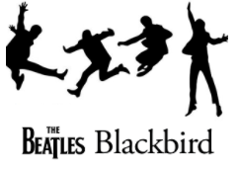

Key Questions –

* Can you find the pulse of the music?
* Can you identify tempo changes?
* Do you like this song? Why?
* How does the music make you feel?
* What instruments can you hear in the music?
* Can you identify the artist?
* Can you complete a simple melody?

Key skills –

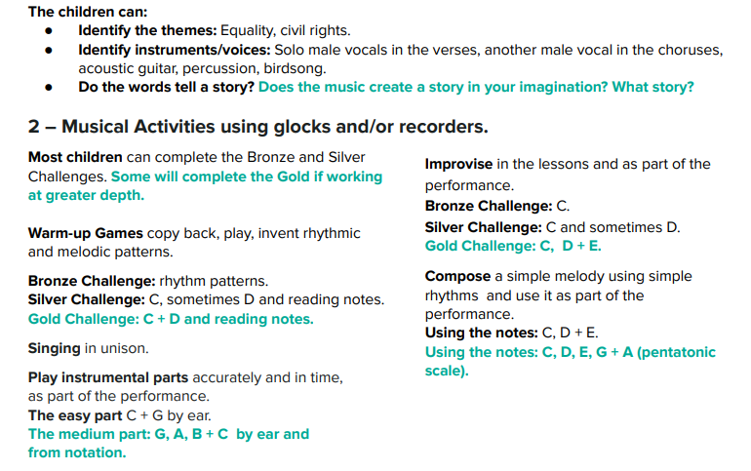

What I will be taught –

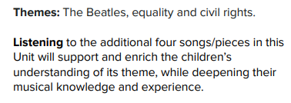

What I should already know –

* How to find the pulse of a song and move to it
* Simple chords on instruments
* Listening to different songs and giving opinions on them
* Simple improvisation with instruments
* Singing in groups
* Different genres of music and how they sound
* The structure of the piece of music

Key vocabulary –

