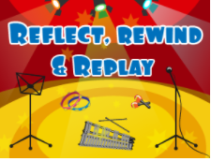

Key Questions –

What instruments can you hear?

Do you like this song? Why?

How is the song put together?

What is the style of Music?

Can you find the pulse?

What is rhythm and pitch?

Key skills –

All skills that have previously been taught in Year 1 with a heavy focus on any gaps that the children have.

See previous knowledge organisers and Charanga.

What I will be taught –

All skills previously taught in Year 1 topics will be recapped and revisited to the children’s needs.

See Charanga

What I should already know –

• Invent, adapt and recount narratives and stories with peers and their teacher.

• Sing a range of well-known nursery rhymes and songs.

• Perform songs, rhymes, poems and stories with others, and (when appropriate) try to move in time with music.

Basic knowledge of using instruments and finding the pulse from previous units.

Key vocabulary –

pitch, pulse, solo, instruments, rhythm, percussion, improvise, compose, perform,