What should I know …  I should know and understand significant aspects of the wider world and the nature and achievements of other civilisations. I should be able to make connections, draw contrasts, analyse trends, frame historically valid questions and create my own structured accounts. I should understand how evidence is used to make historical claims. I should understand historical concepts such as continuity and change and cause and effect.  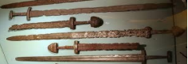 | I will be taught facts on…  - That before the Vikings came, the Anglo-Saxons were living in Britain.  - That the Vikings first came in 793 A.D. from Scandinavia in long ships  - That they initially came as raiders but then came to settle.  - That the Vikings had a reputation for being fierce fighters. That there were many battles between the Saxons and the Vikings to see who would rule.  - That the Viking area of the country was known as Danelaw.  - That when Edward the Confessor died in1066 there were different claimants to the throne | Key Questions …  - How did the Anglo-Saxons and Vikings struggle for the Kingdom of England up to 1066?  - What was life like in Anglo-Saxon times?  - Why and how did the Vikings come to Britain?  - How did the Vikings fight their battles?  - How have historians found out about the Vikings?  - Who were the important people during Viking times?  - How did the Saxons and Vikings interact?  - What was Danelaw?  - Why did three people claim the throne after Edward the Confessor died?  - What happened in 1066?
Key Vocabulary and Definition…  invasion This happens when an army moves into an area in a hostile way  class structure This is the organisation of society from kings and queens to landowners, to farmers and craftsman and finally slaves  battle techniques These include the weapons that were used, the organisation of the soldiers and the targets they chose  Danelaw The area controlled by the Vikings  Battle of Hastings A battle fought in 1066 between an English army and a Norman-French army  Bayeux Tapestry This is an embroidered cloth which tells the story of the Battle of Hasting | Key skills…  - To know about the Viking and Anglo-Saxon struggle for the kingdom of England to the time of Edward the confessor.  - To know and understand the history of these islands as a coherent, chronological narrative from the earliest times to the present day  - To gain historical perspective by placing their growing knowledge into different contexts.  - To understand historical concepts  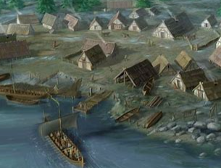 | Web links …  https://www.bbc.co.uk/bitesize/topics/ztyr9j6  ( BBC Bitesize)  https://www.youtube.com/watch?v=X0QnGvl3rJo  (Life in the time of the Vikings)  