What should I know …  I should know how to tell the difference between past and present.  I should be able to show that I understand the past in different ways.  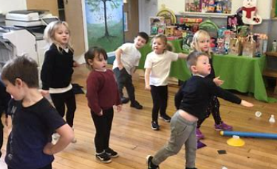 | I will be taught facts on…  I will learn that Hapton School has been here for over a hundred years. I will learn that the school building, and what is taught in it, has changed over time. I will learn that information about schools can be found out in many different ways. I will learn that important national events have happened during the life of Hapton and these can be shown on a timeline.  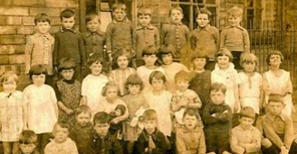 | Key Questions …  - What was Hapton School like in the past?  - Looking at photos, what has changed since the 1950’s?  - What could I ask adults who used to come to Hapton as children?  - How many ways could I find out about schools in the past?  - How was Hapton School in the past different or similar to our school today?  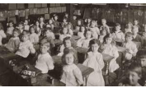
Key Vocabulary and Definition…  Desk This was a piece of furniture where you could work and which held books, paper and pens.  Blackboard This was a smooth, black board which could be written on with chalk.  Bell This was a bell which was rung by hand and was used to bring children in from the playground  Slate This was a piece of slate, set in wood which was used to write on  Abacus This was a counting frame which used beads  Marbles This was a game which children played in the past. | Key skills…  - To recognise the difference between past and present in their own and other people’s lives  - To use sources to ask and answer simple questions about the past  - To understand some of the basic ways the past can be represented  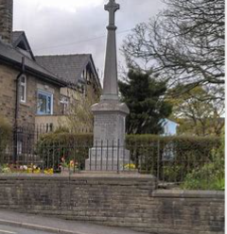 | Web links …  