

**Mathematics at Hapton**

**Class 1- Reception and Year 1**

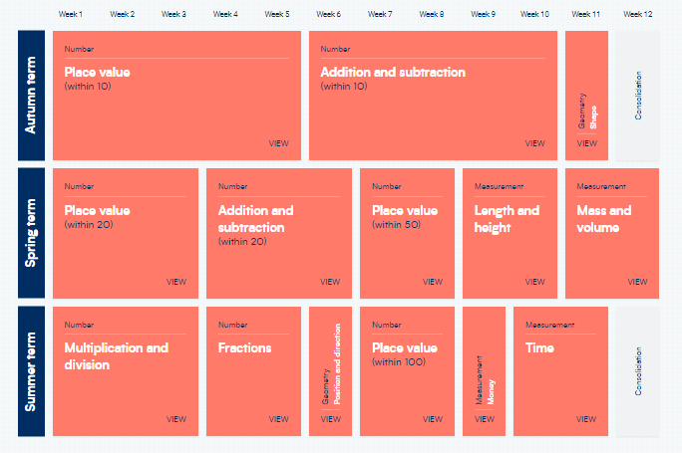**Reception**

**Year 1**

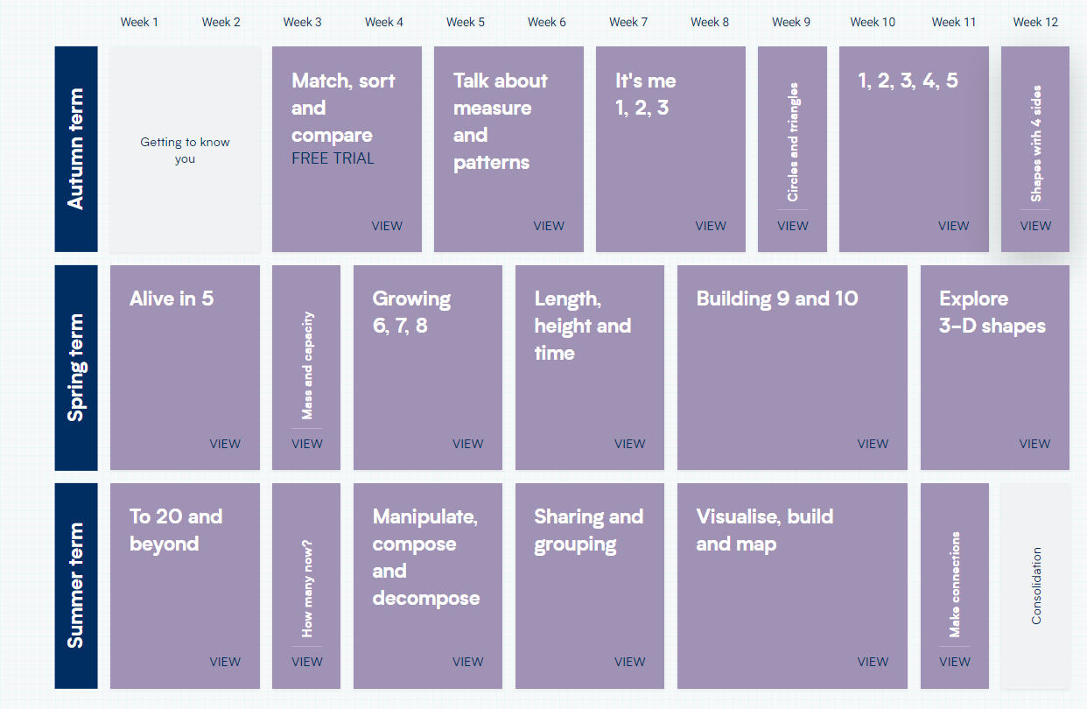



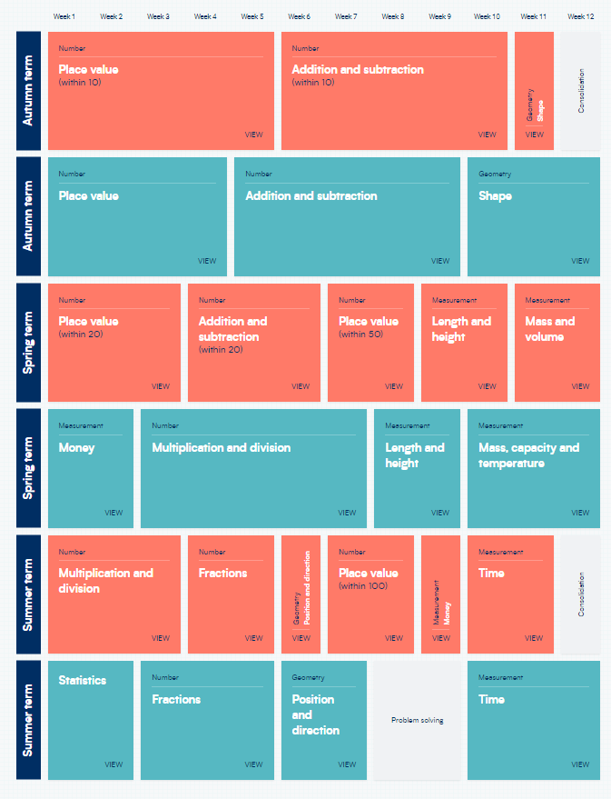

**Class 2- Years 1 and 2**



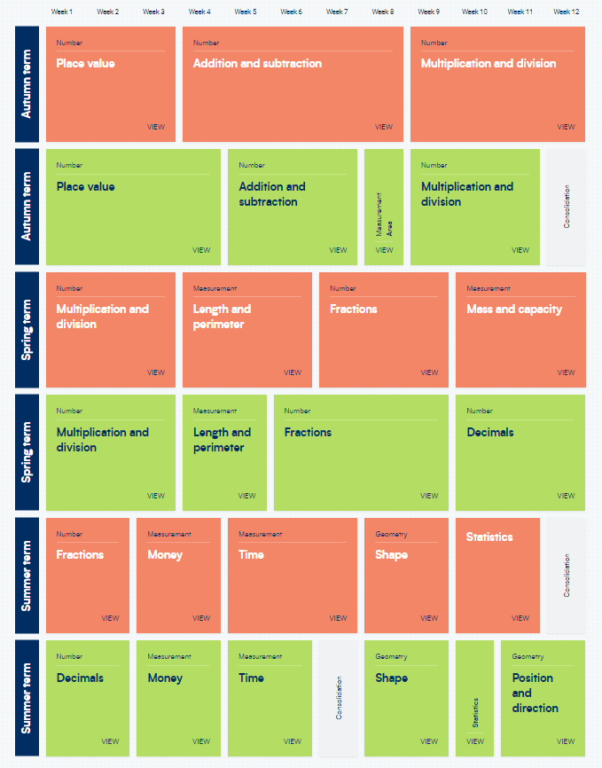

**Class 3- Years 3 and 4**



**Class 4- Years 5 and 6**

