Hapton CE/Methodist Primary School

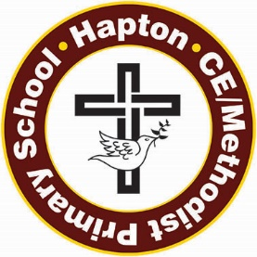

“I will lift up my eyes to the hills, where does my help come from? My help comes from the Lord, the maker of heaven and earth.”
Psalm 121 v 1-2
School Visitor Policy

The aim of this policy is to ensure the safety of pupils, staff and visitors whilst on school premises.

Visitors to school are invited for numerous reasons:
- Providing expertise and guidance
- Building links/raising awareness within the community
- Enhancing the curriculum
- Staff training
- Public relations

Any visitors’ contribution is intended to enhance a specific education experience/topic.

Although visitors should enhance the learning experiences of the children, it should be remembered that they may have no formal training in the classroom environment.

Visitors may need to provided, in advance of their scheduled visit, a detailed breakdown of exactly what materials/resources they intend using, so that their suitability can be checked.

Visitors are always expected to sign in and out of the Visitors book, which is located in the main reception area.

A member of the school staff will accompany visitors to the correct class/meeting room.

Visitors must never be allowed to be on their own with an individual child or a group of children, unless pre-arranged and all correct “disclosure and barring checks” have been carried out and school has sight and/or copies of any relevant certificates.

Visitors must never take photographs/video recordings of children in school. Any requests for photographs, if appropriate, must be made directly through the class teachers.
Visitors are always to be made aware of Fire Drill Regulations and they are made aware of issues of confidentiality at all times.

Review September 2024

